The Averaged Eligibility Map User’s Guide

About the Map

The Averaged Eligibility Map will show you if your summer meal site or day care home is located in an area eligible location based on the USDA Food and Nutrition Service’s averaging policy.

According to USDA policy, day care homes (participating in the Child and Adult Care Food Program) and summer meal sites (participating in the Summer Food Service Program or the Seamless Summer Option) are considered area eligible if located in a census block group (CBG) that, when combined with one or two adjacent CBGs, has a weighted average of 50% or more children eligible for free or reduced-price meals. Each CBG included in the calculation must also have at least 40% of children eligible for free or reduced-price meals (FRP). Census tracts may not be combined.

The purpose of this map is to quickly show you if your summer meal site or day care home is located in a CBG that meets the 50% free and reduced-price area eligibility requirement when averaged with adjacent block groups. This user’s guide will help you to interpret the map and show you how to use the data provided in the map to submit a request to your state agency to get your site formally designated as area eligible.

How to Use This Tool

The map visually displays the results of the weighted averaging calculations by color coding the CBG based on whether an address located there is area eligible, averaged eligible or not area eligible:

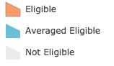

An address is considered “eligible” if it is located in a CBG or census tract with 50% or more FRP eligible children living there. This is consistent with the information provided in the USDA Capacity Builder.

An address is considered “averaged eligible” if it is located in a CBG with 40% of FRP eligible children living there and, when combined with one or two adjacent CBGs, has a weighted average of 50% or more children eligible for free or reduced-price meals. You will need to receive formal approval from your state agency that the site is area eligible according to the averaging policy.

An address is considered “not eligible” if it does not have at least 40% of FRP eligible children living there or does not have a weighted average of 50% or more FRP eligible children when combined with adjacent CBGs.

In accordance with USDA policy, the map calculates rates of FRP eligibility using census data for children 18 years and under and for children 12 years and under. All averaging calculations are done separately—the two types of data cannot be combined. The CBGs are color-coded as “eligible” or “averaged eligible” if they meet the required criteria using either the 18 and under data or the 12 and under data.

Determining if Your Site is Potentially Area Eligible

Step 1: Using the tool bar at the top of the page, type your site’s address into the search bar.

Step 2: Look at the color (orange, blue or gray) of the Census Block Group (CBG) that your site is located in on the map. You can refer to this legend to determine area eligibility status:

Step 3: Click anywhere on the CBG that your site is located in on the map to pull up the pop-up that shows you the relevant data about children eligible for FRP meals living in this CBG. If your site is located in an “averaged eligible” CBG, you will need to use the information contained in this pop-up to get formal approval from your state agency that the site is area eligible according to the averaging policy.

If your site is located in an “averaged eligible” CBG, your pop-up will look like this:

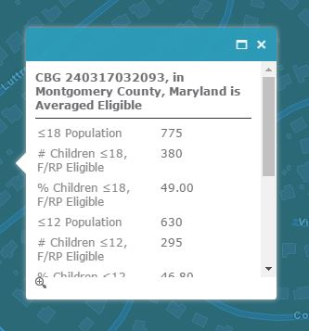

Click on icon in the top right-hand window circled in red to expand the popup and see all of the information:
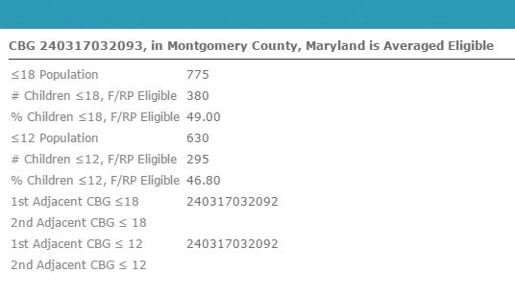

At the top of the pop-up, you will see both the CBG GEOID (identifying number) and the area eligibility status. In the example, the GEOID is 240317032093 and the area eligibility status is “averaged eligible”.

This is the list of the information you will find within an “averaged eligible” CBG popup:

≤18 Population: This is the total number of children 18 and under living in this CBG.

# Children ≤18, F/RP Eligible: This is the total number of children ages 18 and under living in this CBG who are eligible for FRP meals.

% Children ≤18, F/RP Eligible: This is the percentage of children ages 18 and under living in this CBG who are eligible for FRP meals. It is calculated by taking # of Children ≤18, F/RP Eligible ÷ ≤18 Population.

≤12 Population: This is the total number of children ages 12 and under living in this CBG.

# Children ≤12, F/RP Eligible: This is the total number of children ages 12 and under living in this CBG who are eligible for FRP meals.

% Children ≤12, F/RP Eligible: This is the percentage of children ages 12 and under living in this CBG who are eligible for FRP meals. It is calculated by taking # of Children ≤12, F/RP Eligible ÷ ≤12 Population.

1st Adjacent CBG ≤18: This is the GEOID for the adjacent CBG that was combined with this one to make it averaged eligible when using 18 and under data. In the above example, this number is 240317032092.

2nd Adjacent CBG ≤18: This is the GEOID for the second adjacent CBG that was combined to make this one averaged area eligible when using 18 and under data. You will only see a number here if two adjacent CBGs needed to be combined (vs. only one) to reach the 50% FRP eligibility threshold. In the above example, there is no number here.

1st Adjacent CBG ≤12: This is the GEOID for the CBG that was used to make this CBG averaged eligible when using 12 and under data. In the above example, this number is 240317032092.

2nd Adjacent CBG ≤12: This is the GEOID for the second adjacent CBG that was combined to make this one averaged area eligible when using 12 and under data. You will only see a number here if two additional adjacent CBGs needed to be combined with the averaged eligible CBG (vs. only one) to reach the 50% FRP eligibility threshold. In the above example, there is no number here.

Note: All “averaged eligible” CBGs will have at least one number listed under either the “1st Adjacent CBG ≤18” or “1st Adjacent CBG ≤12” field. It is possible to have numbers included in both fields, and for this number to be the same or a different number.

A number will only be included in the “2nd Adjacent CBG ≤18” or “2nd Adjacent CBG ≤12” row if a second CBG was required to reach the 50% threshold.

If your site is located in an “eligible” or “not eligible” CBG, your pop-up will look like this:

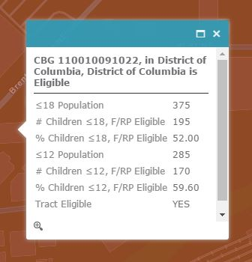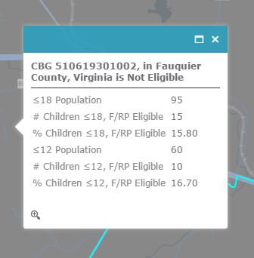

At the top of the pop-up, you will see both the CBG number and the area eligibility status. In the example on the left, the GEOID is 110010091022 and the status is “eligible.” In the example on the right, the GEOID is 510619301002 and the status is “not eligible.”

This is a list of the information you will find within an “eligible” or “not eligible” CBG popup:

≤18 Population: This is the total number of children 18 and under living in this CBG.

# Children ≤18, F/RP Eligible: This is the total number of children ages 18 and under living in this CBG who are eligible for FRP meals.

% Children ≤18, F/RP Eligible: This is the percentage of children ages 18 and under living in this CBG who are eligible for FRP meals. It is calculated by taking # of Children ≤18, F/RP Eligible ÷ ≤18 Population.

≤12 Population: This is the total number of children ages 12 and under living in this CBG.

# Children ≤12, F/RP Eligible: This is the total number of children ages 12 and under living in this CBG who are eligible for FRP meals.

% Children ≤12, F/RP Eligible: This is the percentage of children ages 12 and under living in this CBG who are eligible for FRP meals. It is calculated by taking # of Children ≤12, F/RP Eligible ÷ ≤12 Population.

All eligible CGBs also have an additional field on the pop-up window:

Tract Eligible: This indicates whether the CBG is eligible using tract level data (Yes/No.) It is possible for a CBG to be eligible using either CBG level data or tract level data. In this example, the CBG is eligible using both CBG and tract level data.

Getting Approval from Your State Agency

You can use the information contained in the pop-ups within the Averaged Eligibility Map to get formal verification from your state agency that your site or day care home within an “averaged eligible” CBG is area eligible.

Before following the instructions below, check with your state agency to see if they require you to use a certain table or format to get your site or day care home formally designated area eligible. If they do not require a specific format, you can use the information from the Averaged Eligibility Map to complete and submit a table like this one shown below. Detailed instructions follow, and the last page of this guide features a blank table that includes formulas to automatically do the required calculations.

Type of Census Data Used:
CBG GEOID | Number of Children F/RP Eligible  (Numerator) | Total Number of Children  (Denominator) | Percentage  (must be at least 40%)  =  Numerator/Denominator
Total | Sum of Numerators | Sum of Denominators | Weighted average percent* =  (Sum of Numerators) / (Sum of Denominators)  Do not average percentages

Before completing this table, determine if the CBG is “averaged eligible” using either the 18 and under data or the 12 and under data. You will do this by determining if there is a number listed under either “1st Adjacent CBG ≤18” or “1st Adjacent CBG ≤12” in the pop-up. If there is a number listed in both, choose to use either the ≤18 or ≤12 number(s) but do not use both.

Example
This is how you would complete the first row of the table using this popup as an example (which is averaged eligible based on 12 and under data):

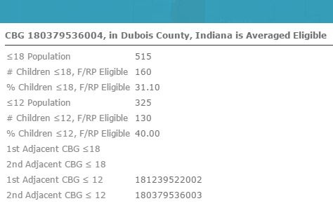

Type of Census Data Used: 12 and under
CBG GEOID | Number of Children F/RP Eligible (Numerator) | Total Number of Children  (Denominator) | Percentage (must be at least 40%) = Numerator/Denominator
180379536004  (averaged eligible CBG) | 130 (# of Children ≤12, F/RP Eligible) | 325 (≤12 Population) | 40% (% Children ≤12, F/RP Eligible)
181239522002
(1st adjacent CBG ≤12)
180379536003
(2nd adjacent CBG ≤12)
Total | Sum of Numerators | Sum of Denominators | Weighted average percent* = (Sum of Numerators) / (Sum of Denominators)  Do not average percentages

To complete the rest of the information for the 1st and 2nd Adjacent CBGs, you will need to find those CBGs on the map and click on each one to bring up their respective popups. Remember, these CBGs will be touching the “averaged eligible” CBG you are already clicked on. You will likely need to zoom out on the map to find them.

This is how this example looks on the map (note: GEOID numbers do not appear on the map, they were added for illustration purposes):

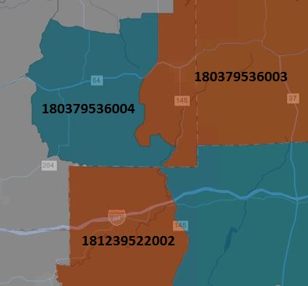

Clicking on the two adjacent orange colored CBGs shows you these popups:

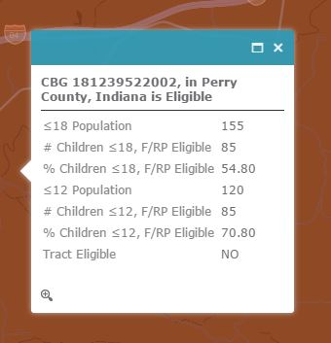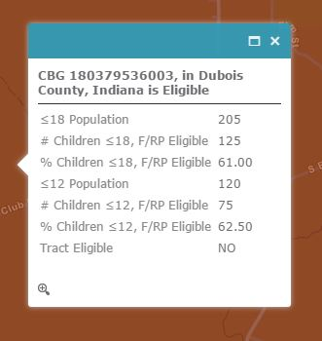

Using the information provided for ≤12 only, you can complete the rest of the first part of the table:

Type of Census Data Used: 12 and under
CBG GEOID | Number of Children F/RP Eligible (Numerator) | Total Number of Children  (Denominator) | Percentage (must be at least 40%) = Numerator/Denominator
180379536004 | 130 | 325 | 40%
181239522002 | 85 (# of Children ≤12, F/RP Eligible) | 120 (≤12 Population) | 70.8% (% Children ≤12, F/RP Eligible)
180379536003 | 75 (# of Children ≤12, F/RP Eligible) | 120 (≤12 Population) | 62.5% (% Children ≤12, F/RP Eligible)
Total | Sum of Numerators | Sum of Denominators | Weighted average percent* = (Sum of Numerators) / (Sum of Denominators)  Do not average percentages

To complete the final row of the table, you will do your own math using the numbers from the first part of the table.

Add all three numerators to complete the “Sum of Numerators” cell. Add all three denominators to complete the “Sum of Denominators” cell. Divide “Sum of Numerators” by “Sum of Denominators to complete the final cell.

Type of Census Data Used: 12 and under
CBG GEOID | Number of Children F/RP Eligible (Numerator) | Total Number of Children  (Denominator) | Percentage (must be at least 40%) = Numerator/Denominator
180379536004 | 130 | 325 | 40%
181239522002 | 85 | 120 | 70.8%
180379536003 | 75 | 120 | 62.5%
Total | Sum of Numerators | Sum of Denominators | Weighted average percent* = (Sum of Numerators) / (Sum of Denominators)  Do not average percentages
 | 290 (130+85+75) | 565 (325+120+120) | 51.3% (290 ÷ 565)

Your table is now complete and ready to submit to your state agency:

Type of Census Data Used: 12 and under
CBG GEOID | Number of Children F/RP Eligible (Numerator) | Total Number of Children  (Denominator) | Percentage (must be at least 40%) = Numerator/Denominator
180379536004 | 130 | 325 | 40%
181239522002 | 85 | 120 | 70.8%
180379536003 | 75 | 120 | 62.5%
Total | Sum of Numerators | Sum of Denominators | Weighted average percent* = (Sum of Numerators) / (Sum of Denominators)  Do not average percentages
 | 290 | 565 | 51.3%

If you’re ready to complete the table yourself, see the next page.

Questions? Comments?
If you have any other questions about how to use the map or feedback on how to make this map better, please contact us at: bestpractices@strength.org

Table for State Agency Approval

(Check with your state agency before completing to determine if they require you to use a state-specific table)

Use this table to complete and submit to your state agency. The table will automatically do all of the required calculations, so you will only need to input the GEOIDs, Number of Children F/RP Eligible, and Total Number of Children values.

To use the table, right click on the table, select “worksheet object” in the pop-up menu and then click “open.” This will open the worksheet in an Excel window where you can input your data from the map. The Excel worksheet will complete the calculations and automatically fill in the table of the Word document.

Site or Day Care Home Provider Name:

Site or Day Care Home Address:

