Instructional Page

Purpose of this Document:
This document is designed to be used by food service staff, principals or other school administrators to address frequently asked Breakfast After the Bell questions from parents.

How to use this Document:
This document can be altered so schools can add in their own contact information, logos, pictures and website links. Schools can remove content in the document that doesn’t apply to them, including the stock photos already in the document, or add in more information to make the document more individualized. The sections that need to be personalized for each school are highlighted in yellow. Use this as a handout for parents, and/or to promote online.

Questions about this document:
For additional questions about this document, contact

Summer Kriegshauser
Program Manager, No Kid Hungry Center for Best Practices
Center for Best Practices
skriegshauser@strength.org

Insert School Logo Here
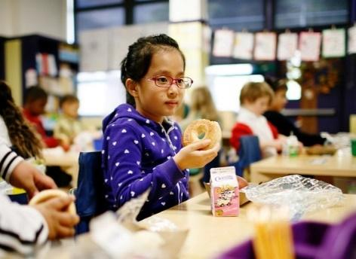
XXX SCHOOL is committed to ensuring that all of our students start the day with a healthy breakfast. Kids who eat breakfast tend to perform better in school, have better attendance rates, and display fewer behavior problems. We know that morning routines can be hectic and many kids aren’t hungry when they wake up and that is exactly why we provide breakfast every morning in a way that allows all students to participate, even after the bell.

XXX SCHOOL serves breakfast in a way that is accessible to students: Pick which breakfast model your school is doing:

Breakfast in the Classroom – breakfast is served to students after the start of the school day in their classrooms. Students have an opportunity during the first 15 minutes of class to eat breakfast with their classmates and get the fuel they need to be ready to learn. Teachers will begin lessons as usual during breakfast time.

Grab and Go to the Classroom – students pick up breakfasts from mobile carts on the way to their classroom. Students have an opportunity during the first 10 minutes of class to eat breakfast with their classmates and get the fuel they need to be ready to learn.

Second Chance to the Classroom – students eat breakfast during a break in the morning, often after first period or midway between breakfast and lunch, and students eat in the classroom. Second Chance breakfast is ideal for students who are not hungry first thing in the morning.

There are many great things about our improved breakfast program. In addition to having access to a nutritious breakfast, eating with classmates every morning creates a community experience, and it takes pressure off parents and caretakers to provide breakfast in the morning. The No Kid Hungry Starts with Breakfast resource is a great way to find out more about the benefits of breakfast, including how kids who eat breakfast do better in math, miss fewer days of school, and are more likely to graduate high school than their peers who don’t eat breakfast regularly.
Insert School Picture Here
Insert School Picture Here

Below are some Frequently Asked Questions about the program:
Insert School Logo Here

HOW DOES IT WORK?
Breakfast is available from X TIME TO 15 minutes after the official start of the school day. Breakfast is available at no cost to all students. OR: Breakfast costs X for full price, X for reduced price, and no cost for those students who qualify.

DOES MY KID HAVE TO EAT SCHOOL BREAKFAST?
Participation in the school breakfast program is voluntary. If you prefer your child not eat breakfast at school, tell your child’s teacher.

WHAT IS BEING SERVED FOR BREAKFAST? IS THE FOOD HEALTHY?
We publish our menu on the school website, in the school newspaper, and we broadcast the menu in the school announcements read each morning over the loudspeaker system. Any food items served at breakfast must meet strict dietary guidelines created by the United States Department of Agriculture (USDA). Milk is served daily, as well as fruit or juice. Entrees are nutritious and easy to eat quickly. Meals often include popular breakfast items such as cold cereal, bagels and string cheese. On “Hot Food Days,” a hot entrée such as a breakfast egg wrap is served. XXX School rotates the menu items every two weeks. We work hard to identify which foods are student favorites, and which foods should be taken off the menu. Additionally, we regularly survey students to gain valuable feedback regarding their breakfast preferences.

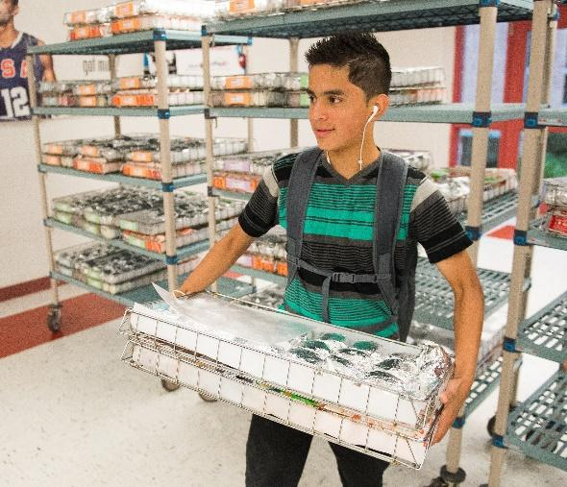
DOES SCHOOL BREAKFAST TAKE AWAY FROM INSTRUCTIONAL TIME?
No! On average, it takes students about 15 minutes to eat breakfast in their classroom. Teachers spend that time constructively on classroom activities, and report that they actually gain instructional time due to fewer disruptions such as visits to the school nurse, tardiness, and absenteeism.

DOES EATING SCHOOL BREAKFAST CONTRIBUTE TO CHILDHOOD OBESTIY?
Research has shown that obesity rates do not increase for kids who eat breakfast at home and at school. In fact, skipping breakfast is associated with a 2.66 times higher risk of being obese or overweight than eating breakfast at home and at school. Kids who eat school breakfast are also more likely to have a better overall diet, eating more fruits, dairy and a variety of foods.

WHAT ABOUT FOOD WASTE?
Through thoughtful menu planning and careful cafeteria practices, we’ve designed our breakfast program to be efficient and effective in providing kids with healthy food to start their day, while also reducing food waste. For instance, XXX School encourages students to take advantage of the “share table” in their classrooms, which allows kids to put food they aren’t going to eat on a table so other kids in the classroom can take it. We allow kids to self-select what breakfast items they want, which reduces the amount of food that ends up in the trashcan. Each classroom allows enough time for kids to finish their breakfast, which also reduces food waste.
Insert School Logo Here
Insert School Picture Here

WHERE CAN I GET MORE INFORMATION?
Contact FNS Director/Cafeteria Manager at PHONE or EMAIL for additional questions/concerns. Keep updated on the school menus HERE. To find out more about No Kid Hungry and the benefits of school breakfast, visit the No Kid Hungry Center for Best Practices.

Wang, S., Schwartz, M. B., Shebl, F. M., Read, M., Henderson, K. E., and Ickovics, J. R. (2016) School breakfast and body mass index: a longitudinal observational study of middle school students. Pediatric Obesity, doi: 10.1111/ijpo.12127.
Wang, S., Schwartz, M. B., Shebl, F. M., Read, M., Henderson, K. E., and Ickovics, J. R. (2016) School breakfast and body mass index: a longitudinal observational study of middle school students. Pediatric Obesity, doi: 10.1111/ijpo.12127.
Basiotis, P. P., Lino, M., & Anand, R. S. (1999). Eating breakfast greatly improves schoolchildren’s diet quality. Nutrition Insight, 15. Alexandria, VA: U.S. Department of Agriculture, Center for Nutrition Policy and Promotion.

