  - Second Chance Breakfast Customizable Letter to Families
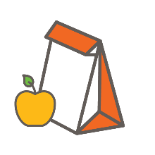

  - About this Resource
  - Parents can be powerful champions for your breakfast program, especially when they understand how it benefits their kids and the overall student body. It is important to inform parents about the details of Breakfast After the Bell engage them in the process.

  - This template letter can be customized by schools to inform families about a Breakfast After the Bell program. See the next page for the customizable letter. Instructions:
- Step 1: Replace the No Kid Hungry logo with your school logo, and replace any pictures in this letter with personal pictures from your school.
- Step 2: Replace any text highlighted in blue with personalized information about your school. Additionally, you can add details where you see fit or remove any content that is not relevant to your school. You also have the option to replace the photo.
- Step 3: Send this letter home to families! You are encouraged to post an electronic version of this letter on your school website or social media channels to further spread the word.

  - Related Resources
- No Kid Hungry’s Breakfast FAQs for Parents (available in English and Spanish) is a customizable resource that answers frequently asked questions from parents about Breakfast After the Bell.
- The USDA’s How Does School Breakfast Help Families? flyer and newsletter inserts are great resources to combine with more personalized information about your school breakfast program.
- For more information about Breakfast After the Bell and other resources, visit: http://bestpractices.nokidhungry.org

Date

Dear Families,
School Name is committed to ensuring that all of our students start the day with a nutritious breakfast. Kids who eat breakfast tend to miss less school, get better grades and are more likely to graduate high school. This letter is to inform you about our Second Chance Breakfast Program.

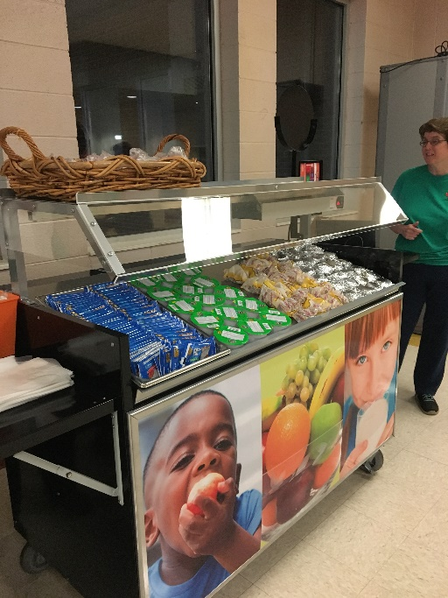
What is Second Chance Breakfast? Students are offered breakfast between first and second periods. Students can pick up breakfast from conveniently located Grab and Go carts, and bring their breakfast to class to eat. Breakfast is still served in the cafeteria before the school day starts.

Why did we make this change? Serving Second Chance Breakfast gives more students the opportunity to eat breakfast at school, at a time that works for them. It removes common barriers like students missing breakfast because they arrive late or because they would rather skip breakfast to hang out with their friends outside of the cafeteria in the morning. Now all students have the opportunity to eat either before school or after first period.

What is served for breakfast? School breakfast always includes milk, fruit or juice, and whole grains. Even though breakfast items provided to students at school sometimes look like the same breakfast items found in stores, school breakfast items have more whole grains and less sugar, sodium, fat and calories. Note here where families can access your school breakfast menu.

How much does school breakfast cost? Note here how much breakfast costs at your school or if school breakfast is available at no cost to all students.

Participating in the school breakfast program is voluntary. We understand that you may prefer to provide breakfast for your child at home. Participating in the school breakfast program is your choice.

PLEASE NOTE: If your child eats breakfast in the cafeteria before the school day starts, he/she will not be able to get Second Chance breakfast without incurring an extra cost. An additional meal will be charged to your child’s school meal account if they eat breakfast in the cafeteria before the school day starts and Second Chance Breakfast.

If you have questions, please contact the Student Nutrition Services department at XXX-XXX-XXXX.
Sincerely,
Name

