No Kid Hungry – Early Childhood Grant Program
In July 2022, the No Kid Hungry Early Childhood Grant Opportunity provided $620K to community-based organizations, early childcare centers, and healthcare providers across the country to support sustainable strategies that increase access to food for young children (0-5 years old) and families facing food insecurity.

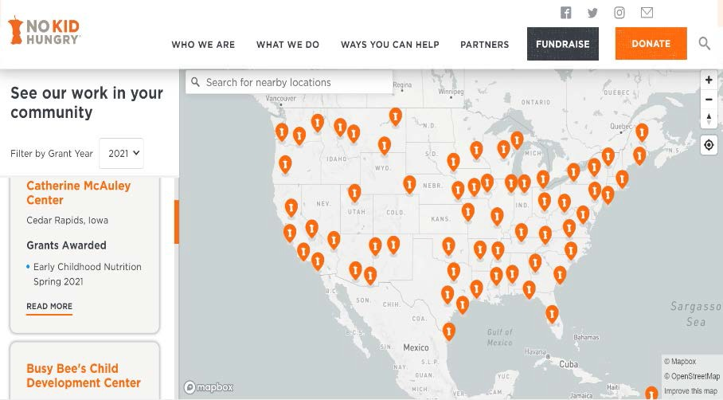

BACKGROUND

The No Kid Hungry Early Childhood Grant Program launched in 2020 in response to the COVID-19 pandemic. Young children, not yet enrolled in school, faced barriers to accessing the food resources available to school-aged children during this time. In response, No Kid Hungry launched the Early Childhood Grant Program and provided emergency relief to support over 100 on-the-ground organizations that work with young children and their families.
To learn more about the NKH Early Childhood grantees visit the No Kid Hungry Grant Impact Portal.
In this second and final year of funding, the focus shifted from emergency relief to an investment in sustainable and innovative strategies that increase access to nutritious food for young children and their families. The grant funds were designed to support 25 grantees from the first year of funding who demonstrated effective and innovative strategies within one of the following three systems:
Grantees represented a total of 15 States (and the District of Columbia) and 5 regions within the U.S.

GRANT OVERVIEW
- Early Childhood System
- Healthcare System
No Kid Hungry distributed $25K grants to all selected organizations.
- Federal Benefits System

This grant also prioritized organizations who:
- Focus their efforts on reaching minority communities, including refugee and immigrant populations and tribal and indigenous communities.
-  Authentically engage the community as partners in decision-making to develop innovative programs that address their unique needs.
- Have a strong and sustainable approach to maximizing participation in child nutrition programs.
Five organizations (20%) focused primarily on addressing food insecurity in Rural Communities.

- Have staff and leadership that are reflective of the community served.


Diverse group of grantees including
childcare centers, healthcare institutions,
and community-based organizations.
100% of grantees focused grant programming on prioritizing & serving communities of color – 16% focused on serving immigrant & refugee children.




TOTAL CHILDREN SERVED
20,493

FINDINGS

TOTAL MEALS SERVED
479,959

OVEREVIEW OF PROJECTS

TOTAL CHILDREN SERVED

Grantees from the healthcare system used grant funds to support food insecurity screening for all patients and to enhance referral processes. They worked to establish an emergency food system within their healthcare system, as well as provided educational resources to inform patients of federal nutrition programs and local, emergency food resources.
Grantees from early childcare centers used grant funds to increase referrals and enrollment in WIC and SNAP, provide nutrition counseling services, provide free access to fresh fruits and vegetables through an on-site community garden and greenhouse, and host workshops on WIC and SNAP benefits with direct support from culturally responsive staff members.
Grantees from the nonprofit sector who used grant funds to support the Federal Benefits system provided outreach and education services, facilitated cooking demonstration workshops, implemented telehealth to modernize their WIC program, and provided benefits application assistance.

COMMITMENT TO EQUITY

In our commitment to racial equity, we encouraged organizations to center the young children and families in their respective communities to ensure equitable, culturally competent delivery of program strategies.
Organizations implemented several strategies to support our commitment to equity in programming. See a few strategies below:

PROGRAM CHALLENGES
Collect data on experiences of bias and racial equity to inform staff development and program design.
Integrate bilingual or multilingual options for services and program materials.
Community-driven strategies created with an equity lens that involve community members in decision-making to shape interventions.
Representation of community in hiring practices, organizational leadership, and advisory committees.

In the final reports, Grantees reflected on the challenges and barriers they faced during this grant period. NKH Early Childhood Grantees identified program challenges as the following:

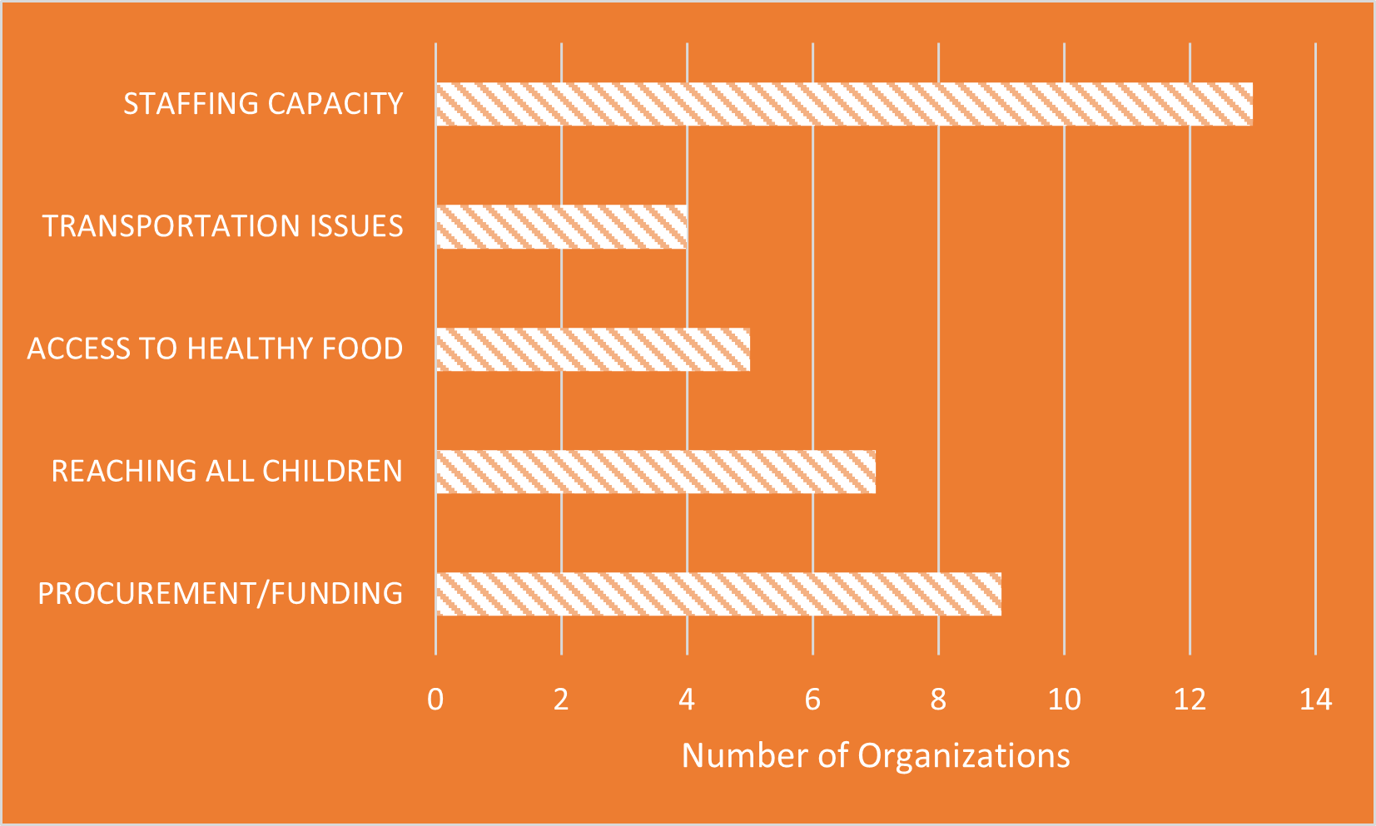

GRANTEES SUSTAINABILITY STRATEGY

Grantees expressed their commitment to sustainability and the continuation of their efforts after the grant cycle ended in July 2023.

Strategies for sustainability include:
- Prioritize community ownership and community assets
- Utilize lessons learned to inform the scaling of current efforts
- Maximize new community partnerships and increase collaboration
- Involve local stakeholders in planning, implementation, and evaluation

PROGRAM SUCCESSES

This second round of No Kid Hungry Early Childhood grants invested in the efforts of organizations with a demonstrated commitment and expertise in implementing sustainable strategies to address the gap in resources and services for young children across the Nation. The lessons learned continue to inform the key strategies of the Early Childhood Systems team.

“In January 2023 and again in May, we found ourselves tending to the needs of several large migrant/refugee families that had recently arrived in Chicago from South America. While we are not equipped to provide resettlement or immigration services, we could not turn away those who ended up on the doorstep of the Quinn Center. The housing agency responsible for them asked to use some of our space as a temporary day shelter and we obliged. As our single case worker went individual by individual to assess the needs of each family, our program staff made sure that everyone (including numerous children) was fed for weeks on end. We would not have been able to do this without the flexibility and support of funding from organizations like No Hid Hungry.”

Quinn Center of St. Eulalia (Maywood, IL)

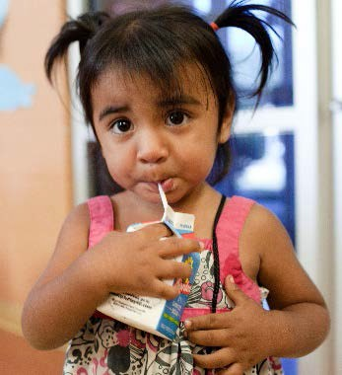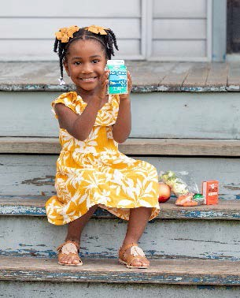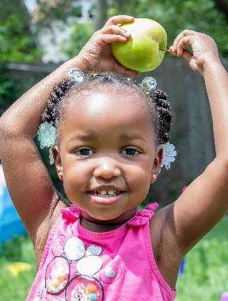TESTIMONIALS

“We are pleased that our families of color are served through connections to resources that provide access to better nutrition decreasing food insecurities and improving health outcomes. One client in particular is a 31-year-old Nepali mom who at the time of enrollment into our program was 3 months pregnant with a 3-year-old toddler. The mother presented with health issues centered around improper and inadequate nutrition. Our Nepali Community Health Worker enrolled her in the WIC and SNAP program and connected her to prenatal services. After months of engagement with this client she delivered a healthy baby and her health had improved exponentially. The 3-year-old toddler is healthy and happy, and we still continue to engage this client for continued healthy outcomes.”
Wellness First (Columbus, OH)

“As mentioned, since the beginning of the year we have seen a significant influx of clients who are living in the New York City shelter system, including families with young children. This grant has enabled us to reach a broader variety of community members, including those living in shelter. One undocumented family came to us for food to help feed their children while living in the shelter. They have returned to AAFSC a few times for additional food and have also become ambassadors of our programming, spreading the word about our services to other families living in shelter. Given language barriers and the difficulty accessing shelters, this kind of word of mouth outreach is invaluable, and we are incredibly grateful to the clients who share information about our programs with their communities.”
Arab American Family Support Center (Brooklyn, NY)

“On Wednesdays at The Village Institute, we host the Pamoja Village Program - a teacher education program for refugee women. Because we were able to hire a Food and Nutrition Program Coordinator with funds from this grant, we were able to have a dedicated staff member to ensure that all program participants had access to our on-site food pantry for themselves and their families. Each Wednesday, Lah Gay Moo, our Food and Nutrition Program Coordinator, would prepare 30 boxes of food for participants to take home. Participants were incredibly grateful, and more participants registered for the program with this as an added incentive. Our food pantry was named "The Village Isoko" by our program participants, which is the Swahili word for Market. The Isoko was open to all families and participants, regardless of income or status, to avoid stigmas of accessing free food.”
The Village Institute (Aurora, CO)

