Canva link: https://canva.link/vlktx2m03rpnsxl

Summer EBT 101

Summer EBT (or SUN Bucks) is a new federal nutrition program that provides $120* per eligible child in grocery benefits each summer, when kids aren’t getting the meals they usually eat at school. Benefits are typically provided on a debit-style EBT card to purchase food at approved retailers including grocery stores, farmers markets, and online. Benefits expire 122 days (about 4 months) after they are issued and cannot be used after that point.
Summer EBT is one of multiple new options that help ensure children have food during the summer months when school is out. Children and families can participate in both Summer EBT and free summer meals, whether congregate or non-congregate.

*The benefit amount varies in Alaska, Hawaii, and US territories and will adjust with inflation each year. Children can only receive Summer EBT if they live in a state, territory or tribal area that has opted in to administering the program.

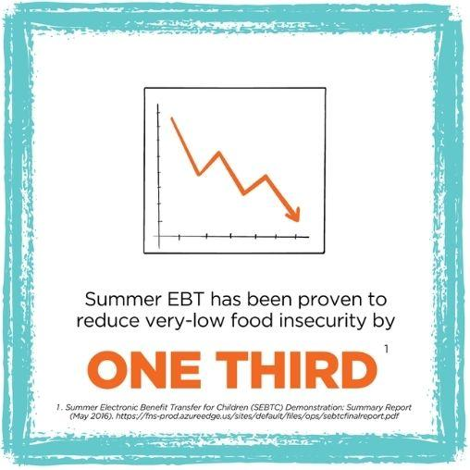

Eligibility & Enrollment

Children may be automatically eligible and enrolled if:
- They attend a school that participates in the National School Lunch Program (NSLP) and/or School Breakfast Program (SBP).
  - are approved for free or reduced-price meals at their school, or
  - participate in certain public benefits, such as the Supplemental Nutrition Assistance Program (SNAP).
- They do NOT attend a NSLP/SBP school but they meet specific age requirements and are enrolled in certain public benefits.

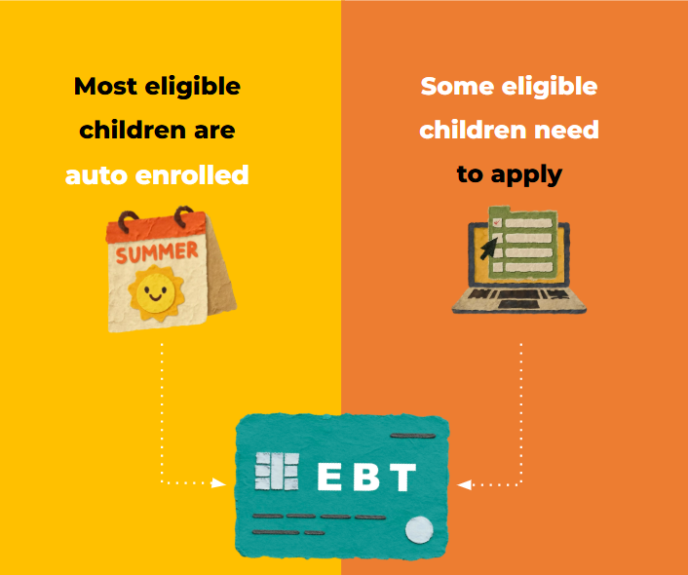
Children are eligible by Summer EBT application if:
- Their household meets certain income guidelines (185% of the federal poverty level) and attends a school that participates in NSLP.

Key Eligibility Notes:
- Children and families can participate in both Summer EBT and summer meals, whether congregate or noncongregate
- The specific programs used to qualify a child for automatic Summer EBT enrollment vary by state.
- Age requirements vary by state and only apply to children NOT attending an NSLP school. Students of any age who are income-eligible and attend an NSLP school are eligible for Summer EBT.
- Most public and charter schools, as well as some private schools, participate in NSLP.

Summer EBT Eligibility for Students in Free School Meals for All Contexts (CEP or universal meal programs)
Understanding eligibility and enrollment can be confusing for households, particularly if they have students receiving free school meals through the Community Eligibility Provision (CEP) or other universal free meal programs. Because these schools do not collect individual free or reduced-price school meal applications—or families may be less likely to complete them since meals are provided at no cost—fewer students are identified for automatic Summer EBT enrollment through being approved for free or reduced-price school meals. As a result, some income-eligible students may not be automatically enrolled and should apply through their state.

Resources & Support

Summer EBT is a new program and looks different in each state, territory and tribal area that administers it, including when automatic issuance happens, when application deadlines occur, and how communication goes out to families. Below is a list of websites that offer up-to-date information about Summer EBT:

- SummerEBT.org - helps families check if they are likely eligible for Summer EBT by answering a few simple questions and directs them to state-specific information and next steps. This is a great resource to share–especially with multi-state audiences–since it provides clear, state-specific eligibility guidance in one place.Scan the QR code to check out your state’s information!
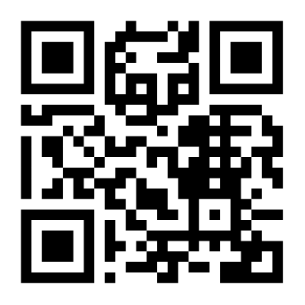

- USDA’s Sun Bucks (Summer EBT) - provides Summer EBT information about states, including state agency, territory and tribal websites where more details can be found, including application deadline information, and customer support hotlines.

- No Kid Hungry’s Summer EBT Basics for Families - provides a helpful overview of Summer EBT, specific to families, and includes information on eligibility guidelines, ways to apply for Summer EBT, and information about SNAP and WIC.

- No Kid Hungry’s Summer EBT Overview and Resources - provides an overview of Summer EBT, along with information for state agencies, and resources to support outreach to families.

